Static Timing Analysis for Nanometer Designs: A Practical Approach 2009th Edition

VLSI Physical Design: From Graph Partitioning to Timing Closure

Constraining Designs for Synthesis and Timing Analysis: A Practical Guide to Synopsys Design Constraints (SDC)

Digital VLSI Systems Design: A Design Manual for Implementation of Projects on FPGAs and ASICs Using Verilog By Seetharaman Ramachandran

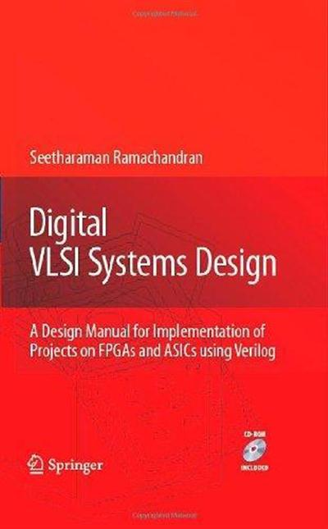



Principles of VLSI RTL Design: A Practical Guide

Sanjay Churiwala,Sapan Garg

CMOS VLSI DESIGN

VLSI Design and Test for Systems Dependability

Cours:

http://www.cs.uoi.gr/~tsiatouhas/CCD/

http://www.ee.ncu.edu.tw/~jfli/vlsi21/lecture/



https://www.huffingtonpost.fr/2018/07/21/affaire-alexandre-benalla-larchive-de-quotidien-qui-tombe-tres-mal-pour-macron_a_23486785/?utm_hp_ref=fr-homepage

http://www.groupes.polymtl.ca/ele6306/pages/cours.php#1

http://pagesperso.univ-brest.fr/~bounceur/cours_pdf/ves/ves_cours1.pdf

ATPG for sequential logic is still difficult because, in order to propagate the effect of a fault to a primary
output so it can be observed and detected, a state sequence must be traversed with
the fault undertaken. For large sequential circuits, it is difficult to reach 100% fault
28 VLSI Test Principles and Architectures
coverage in reasonable computational time and cost unless DFT techniques are
adopted [Breuer 1987

Fault simulation
A fault simulator emulates the target faults in a circuit in order to determine which
faults are detected by a given set of test vectors. Because there are many faults
to emulate for fault detection analysis, fault simulation time is much greater than
that required for design verification. To accelerate the fault simulation process,
improved approaches have been developed in the following order. Parallel fault
simulation uses bit-parallelism of logical operations in a digital computer. Thus,
for a 32-bit machine, 31 faults are simulated simultaneously.

Test generation is the task of producing an effective set of vectors that will achieve
high fault coverage for a specified fault model

The objective of
test generation is the task of producing a set of test vectors that will uncover any
defect in a chip.

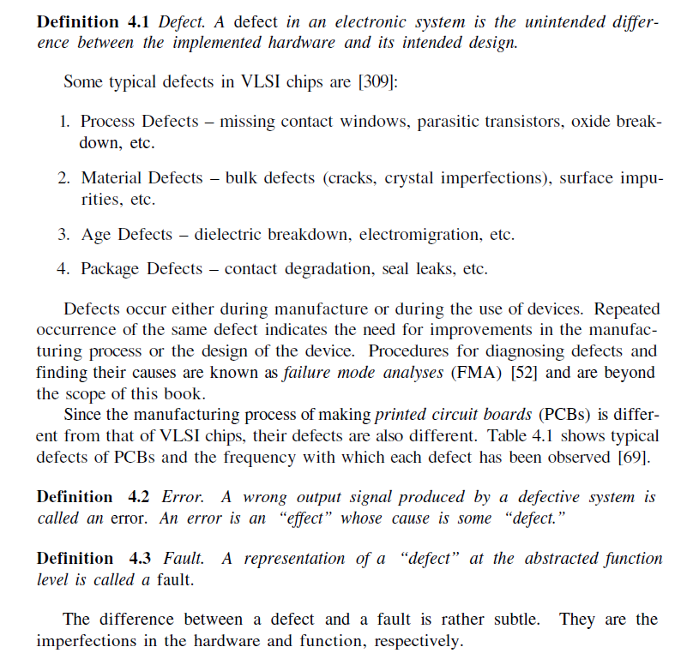

Example
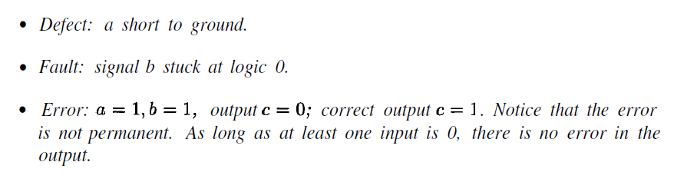

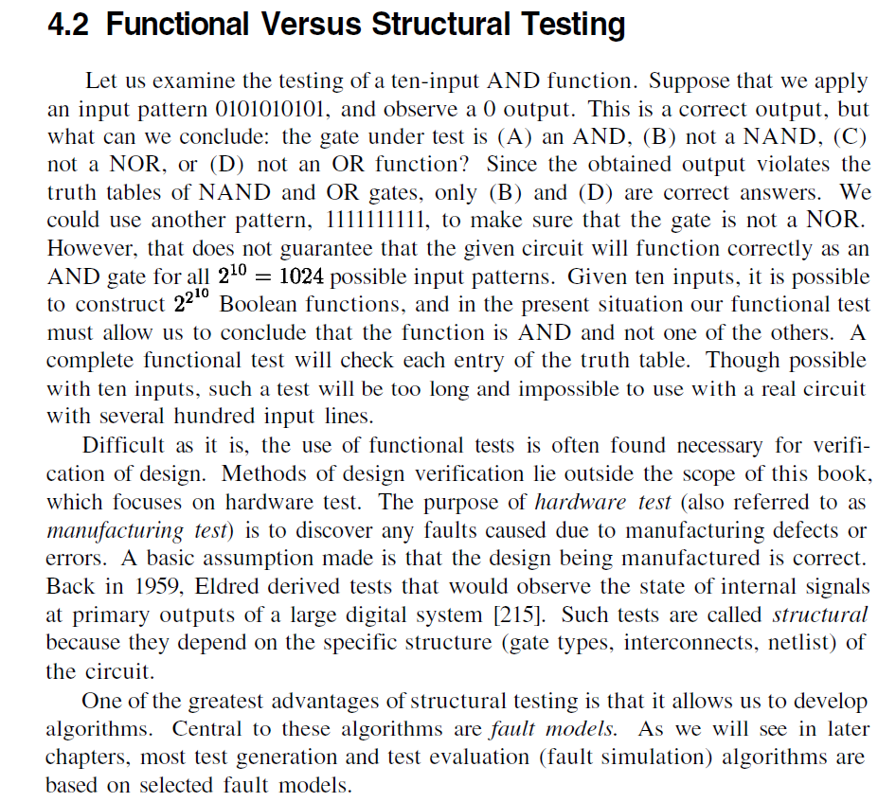

Redondant ???

Operations on digital hardware:
– Inject fault into circuit modeled in computer
– Use various ways to activate
and propagate fault effect through
hardware to circuit output
– Output flips from expected to faulty signa

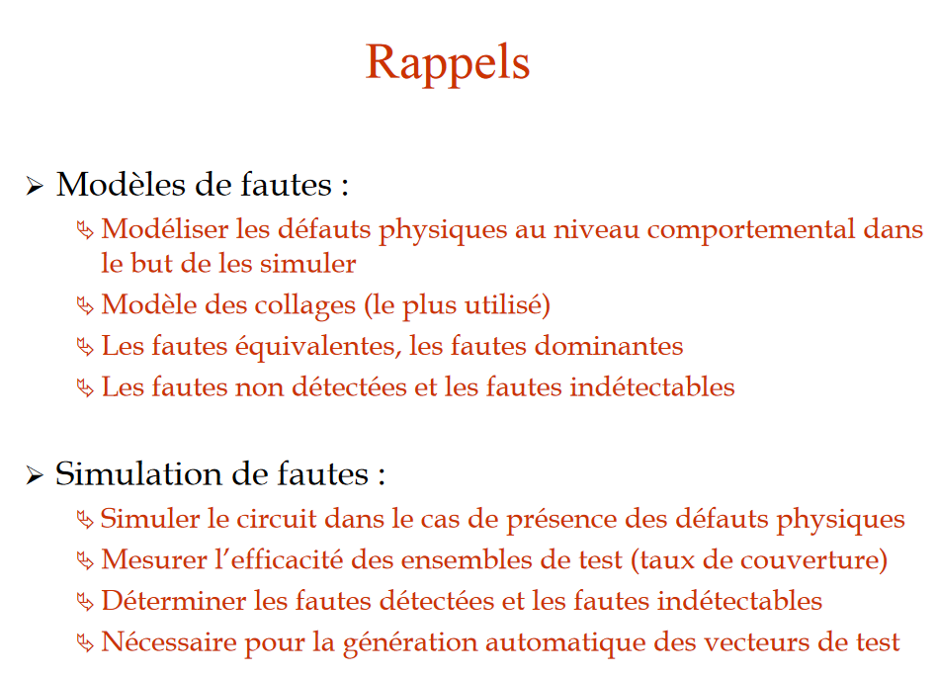
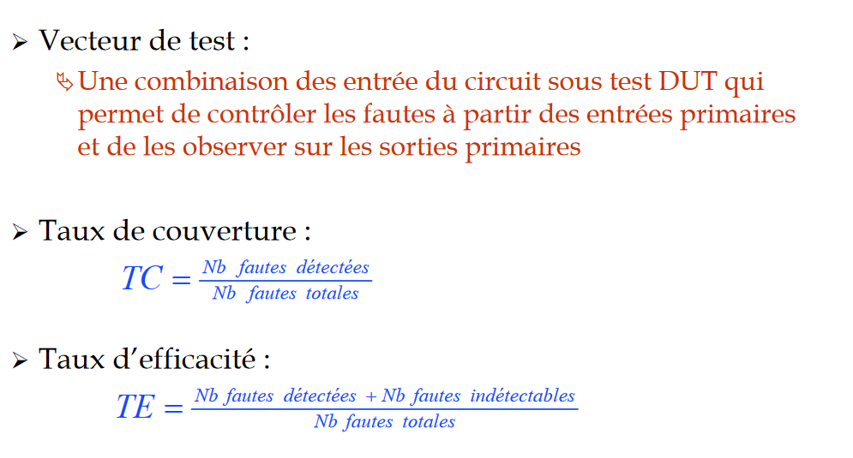
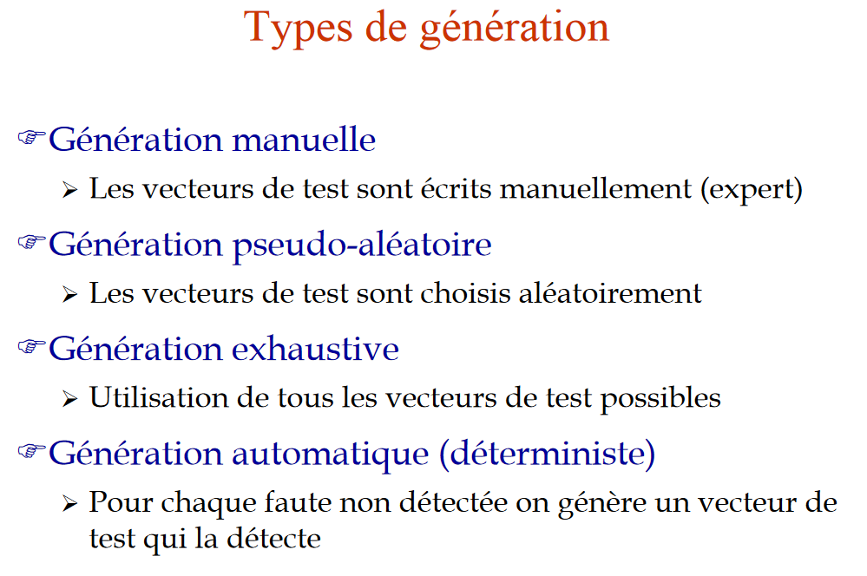

https://www.academiepro.com/uploads/cours/2015_09_08_ele6306_chap5_ATPG.pdf

C’est le programme qui permet de déterminer des vecteurs de test spécifiques pour détecter des fautes données

http://pages.hmc.edu/harris/cmosvlsi/4e/lect/lect12.pdf

http://web.stanford.edu/class/ee386/public/DelayFault_6_per_page.pdf

transistion delay
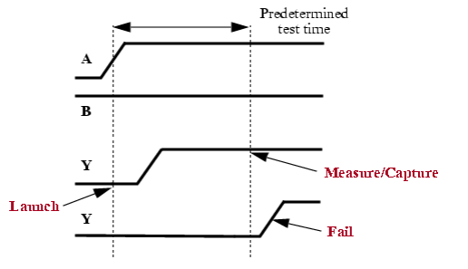
At-Speed Test
Timing failures can occur when a
circuit operates correctly at a sl
ow clock rate, and then fails
when run at the normal system
speed. Delay variations exist in
the chip due to statistical
variations in the manufacturing process, resu
lting in defects such as partially conducting
transistors and resistive bridges.
The purpose of at-speed testing is
to detect these types of probl
ems. At-speed testing runs the
test patterns through the circuit
at the normal system clock speed.

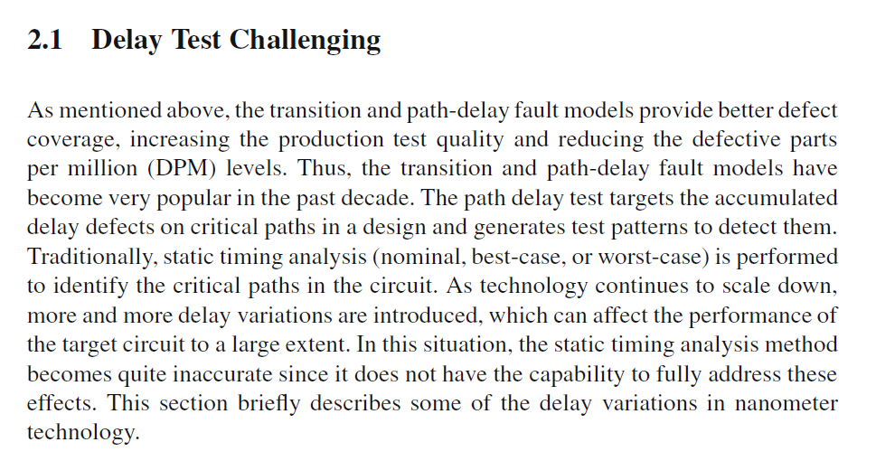
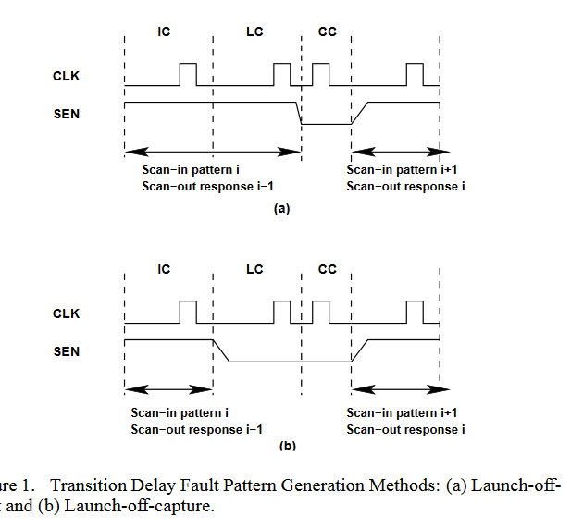
https://www.eetimes.com/document.asp?doc_id=1216938

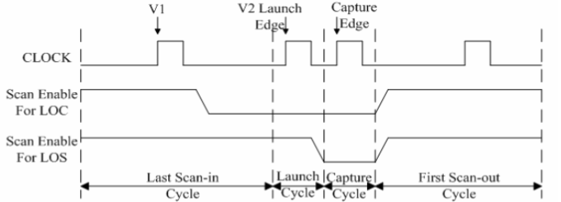

https://tel.archives-ouvertes.fr/tel-00481534/document

http://www.lirmm.fr/~virazel/COURS/M2%20-%20HMEE327/Cours/HMEE327.pdf

http://www.lirmm.fr/~girard/PDF/CoursEGIM_PDF/Chapitre5
http://www.groupes.polymtl.ca/ele6306//data/ele6306_chap4_FaultSimulation.pdf
http://www.groupes.polymtl.ca/ele6306/pages/cours.php
https://tel.archives-ouvertes.fr/file/index/docid/669605/filename/otp_0352.pdf +++

The purpose of a fault simulator is to determine the effects of faults on the behavior of the circuit and to evaluate the quality of the test vector sets by calculating the coverage to a given fault model.
The purpose of automatic generation of test vectors (ATPG) is to obtain a minimal set of test vectors that can detect the maximum number of faults.
The major difficulty of ATPGs for digital circuits lies in the significant complexity of the circuits.

https://www.enseignement.polytechnique.fr/profs/physique/Francois.Anceau/Phy568/Amphis/cours9.pdf +++
Intégration des Systèmes
Notions de test et testabilité Michele.Portolan@imag.fr

